|  |
| --- |
| Purchase Features List  Super petro chemical limited |
| REFERENCE: GW/ERP/Features list |
|  |
| **Genweb2 Ltd.** |
| **23-Nov-21** |



|  |
| --- |
|  |

# Document Information

|  |  |
| --- | --- |
| Document Name | Procure to Pay Features List |
| Document Author | Rashedul Alam |
| Document review | Mahfuzur Rahman |
| Document Version | 1.1 |
| Release Date | 23th Nov, 2021 |

# Document History

|  |  |  |  |  |  |
| --- | --- | --- | --- | --- | --- |
| A=Added, M=Modified, D=Delete | | | | | |
| **Version No** | **Date** | **Section No** | **A/M/D** | **Description of Change** | **Author** |
| 1.0 | 23-Nov-2021 |  | A | Initial | Rashedul Alam |
| 1.1 | 30-Nov-2021 |  | A/M | Vendor bill payment remove, PR info reports Add ,MMR view from PO add | Rashedul Alam |

Contents

A. Document Information 2

B. Document History 2

1. Introduction 4

1.1 Procure to pay process flow 4

2. Purchase requisition 4

2.1 PR Creation by Inventory user or Manager 5

2.2 PR Validate by Plant In charge 6

2.3 PR approval by Head of procurement 7

2.4 Approved PR (Local) View by Purchase user (Local)/Manager 10

2.5 Print PR View from approved PR by Purchase user/Manager 11

3. Send RFQ 12

3.1 Send RFQ create by Purchase user (Local)/Manager 12

4. Comparative Bid Study 13

4.1 Comparative bid study analysis by Purchase user (Local)/Manager 14

5. View Purchase quotation 15

5.1 View Purchase quotation by Purchase user (Local)/Manager 15

6. Purchase order 16

6.1 Confirm Purchase order by Purchase user (Local)/Manager 16

6.2. View Purchase order 17

6.3. Print PO View from approved PO by Purchase user/Manager 18

6.4. MRR PO against view by Purchase user/manager 20

7. Vendor Bills 21

7.1 Vendor bill creation PO against initiate by Procurement user 21

8. Reports 24

8.1 PR info Report view by Procurement user/Manager 24

8.2 Purchase Requisition Summary Report view by Procurement user/Manager 25

8.3 Pending purchase local reports view by procurement user/ Manager 26

# 1. Introduction

The purposes of this Features list is to clearly identify the customer requirements and provide a detailed document. The customer will read this document and get a clear view procure to pay module. It will also help the review team to validate whether the customer requirements have been fulfilled or not.

## Procure to pay process flow

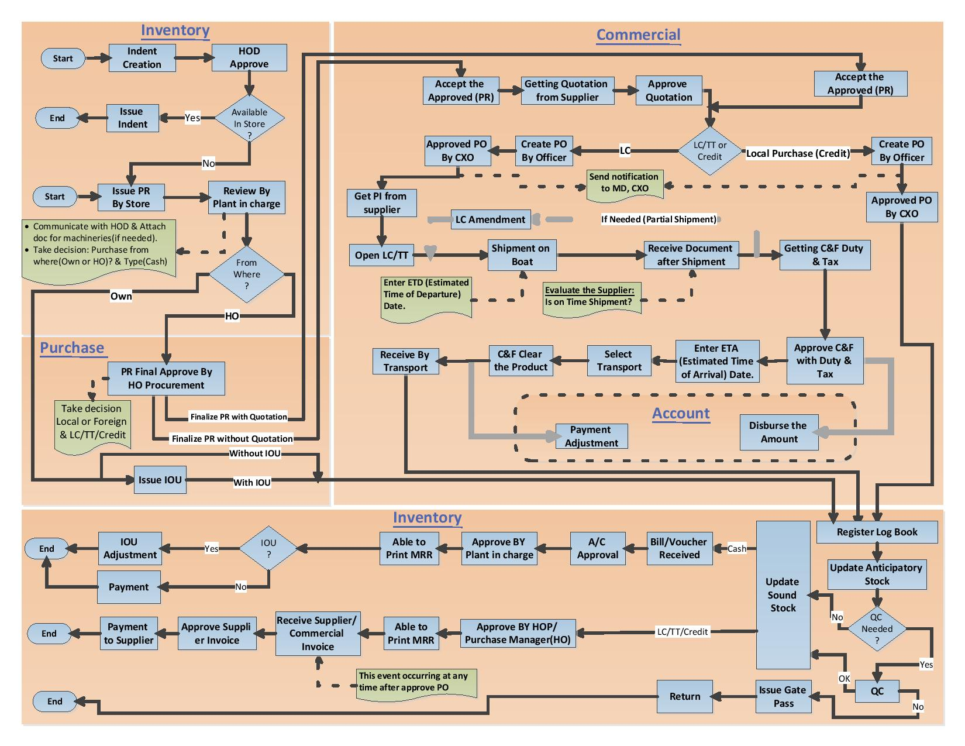

Figure: Procure to pay process flow

# 2. Purchase requisition

A purchase requisition is a formal document that is used when an employee needs to purchase or order something on behalf of their organization. This document informs the Inventory managers or Inventory user of the decision so the purchasing department can start the process of purchasing the requested products or services.

**PR Number:** System will generate auto a unique PR no after Issue. Here will first operating number then Year then unique a number.

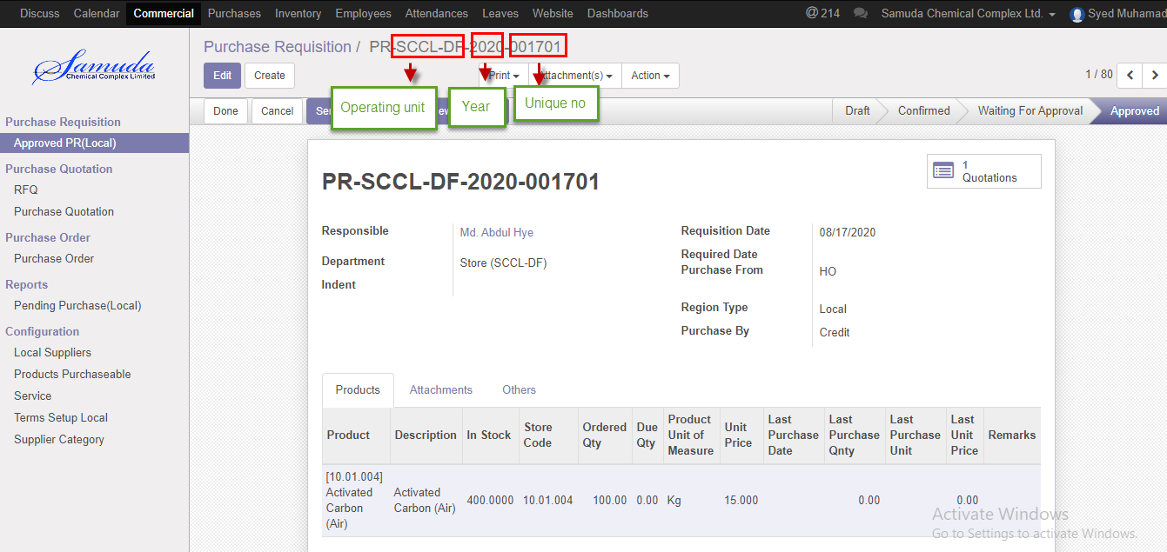

Figure: PR no

## 2.1 PR Creation by Inventory user or Manager

PR will be created/Edit by Inventory user/Manager.

PR is possible for with indent and without indent

PR is possible with multiple indents if user want.PR no has system generated.

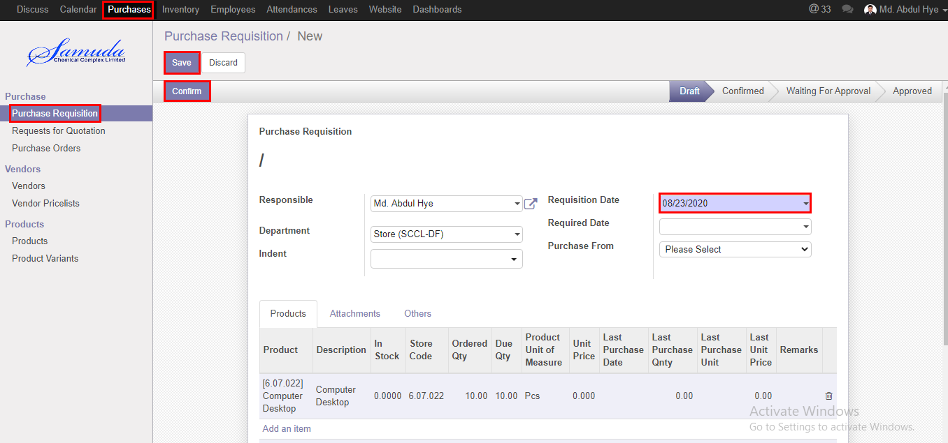

Figure: PR Creation

## 2.2 PR Validate by Plant In charge

Validate PR by click **Validate** Button. Validate by Plant in charge.

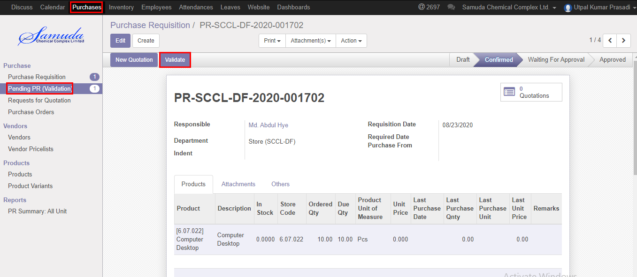

Figure: PR validate

After click Validate button will open following window then Select purchase from, Region type, Purchase By and then **save**

If select own then will go for Issue IoU and select HO then will go for HO procurement for Final approve**.**

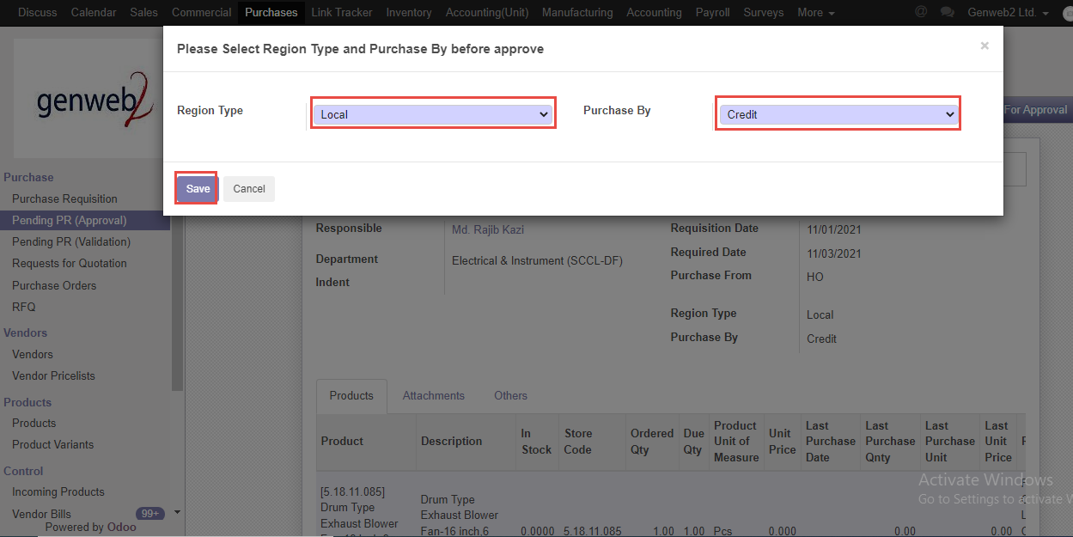

Figure: Purchase from window

## 2.3 PR approval by Head of procurement

After Validate the PR Head of Procurement will get the notification.

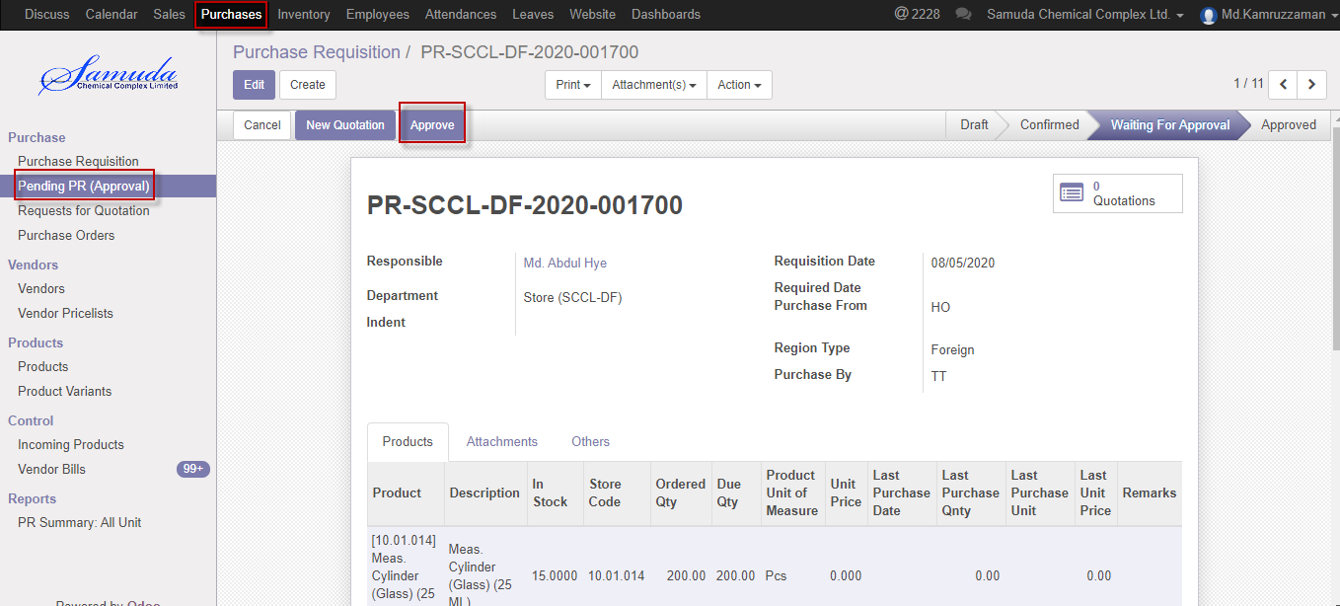

Figure: Pending PR waiting for approval

Following window will open after click **Approve** button then select region type & Purchase by

Select region type Local and also will select Purchase by which method Cash,Credit.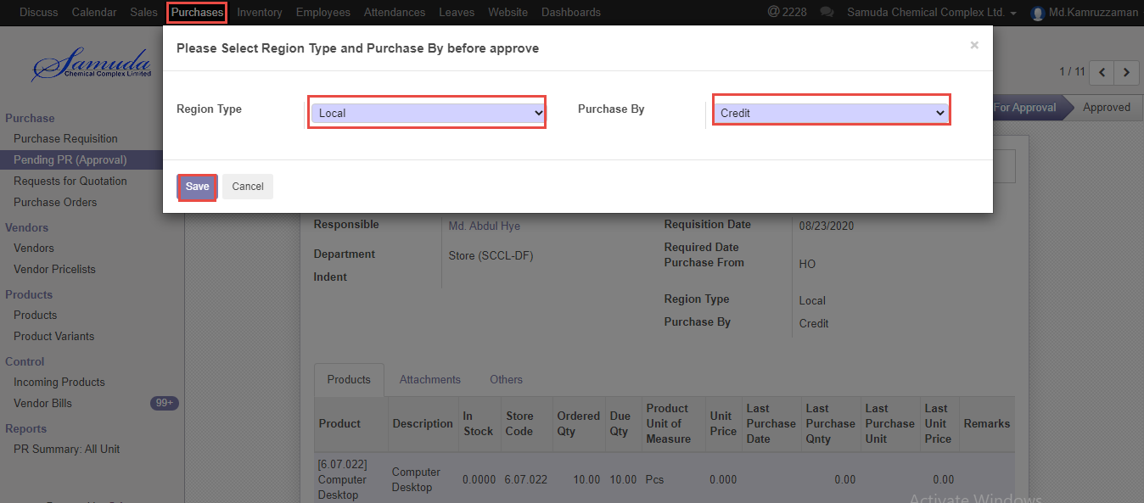

Figure: Purchase method

Following window will open after click **save** button then will ready for New Quotation .New quotation Approve by Head of procurement. 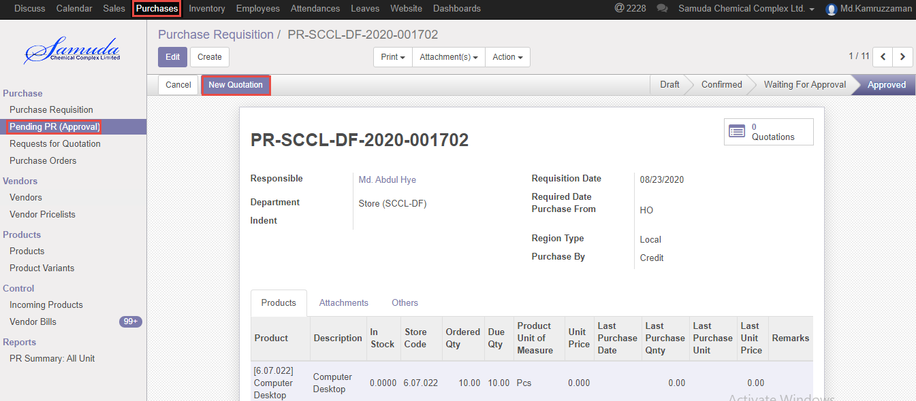

Figure: Create new quotation

Click New quotation button & Select supplier after select all info will come auto and head of procurement is capable to edit then Click **Confirm order** button. Confirmed By Head of Procurement.

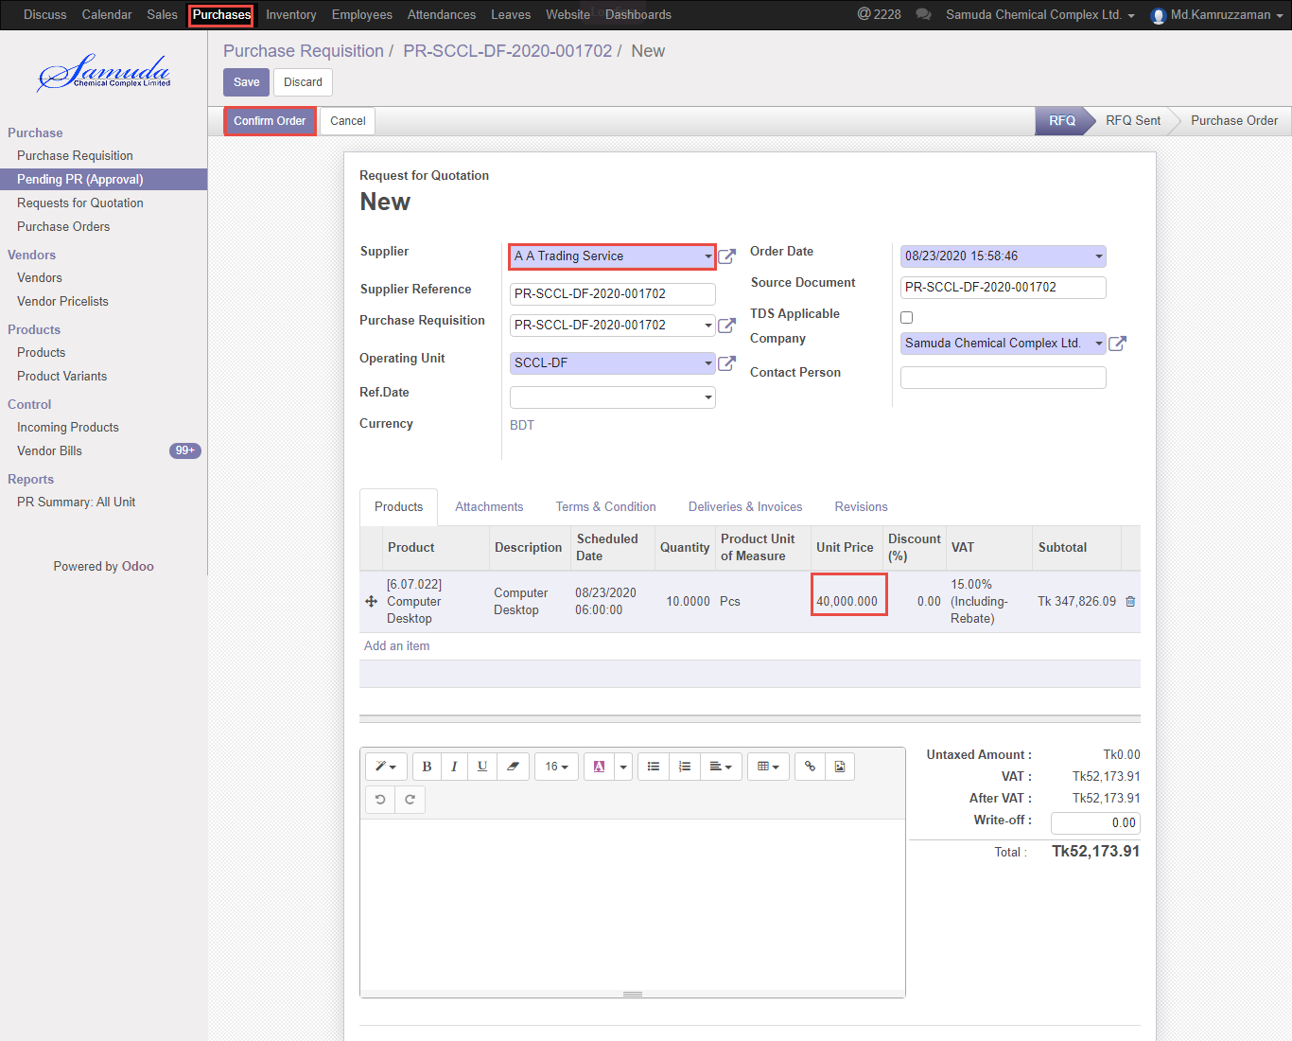

Figure: Confirm order

Following window will open after click Confirm order Button then select region type & purchase by then save then Click Purchase order button then finally Purchase order will approve.

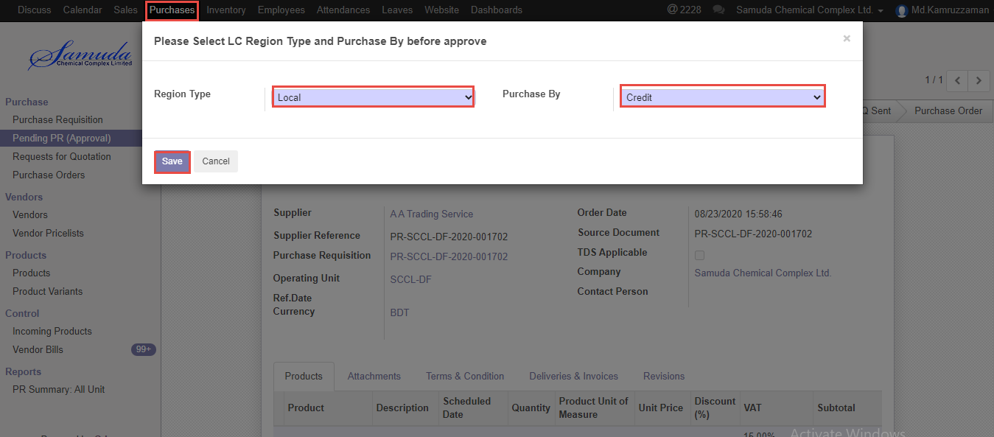

Figure: Purchase method

## 2.4 Approved PR (Local) View by Purchase user (Local)/Manager

Approve PR will view by procurement user/manager.

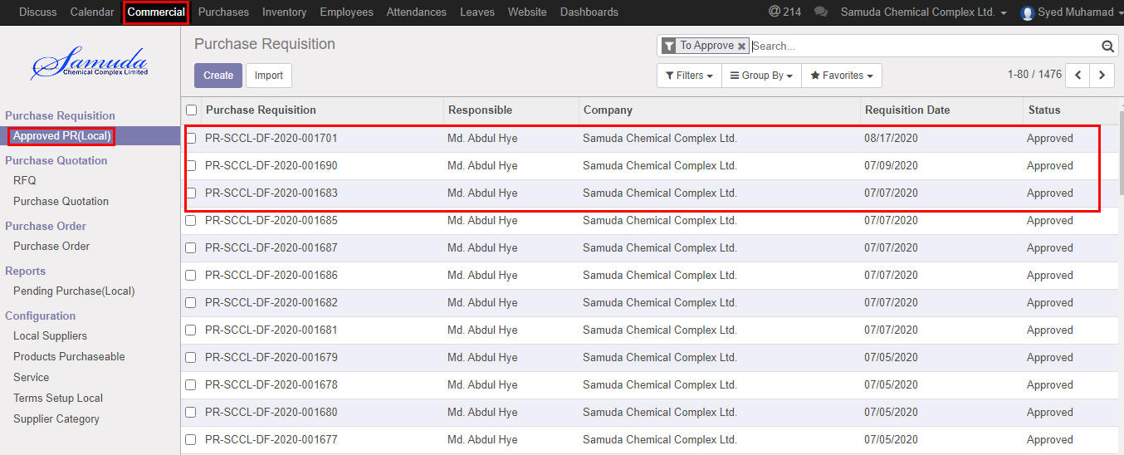

Figure: Approved PR (local) List view

## 2.5 Print PR View from approved PR by Purchase user/Manager

Purchase user/manager also capable to print PR from approve PR.

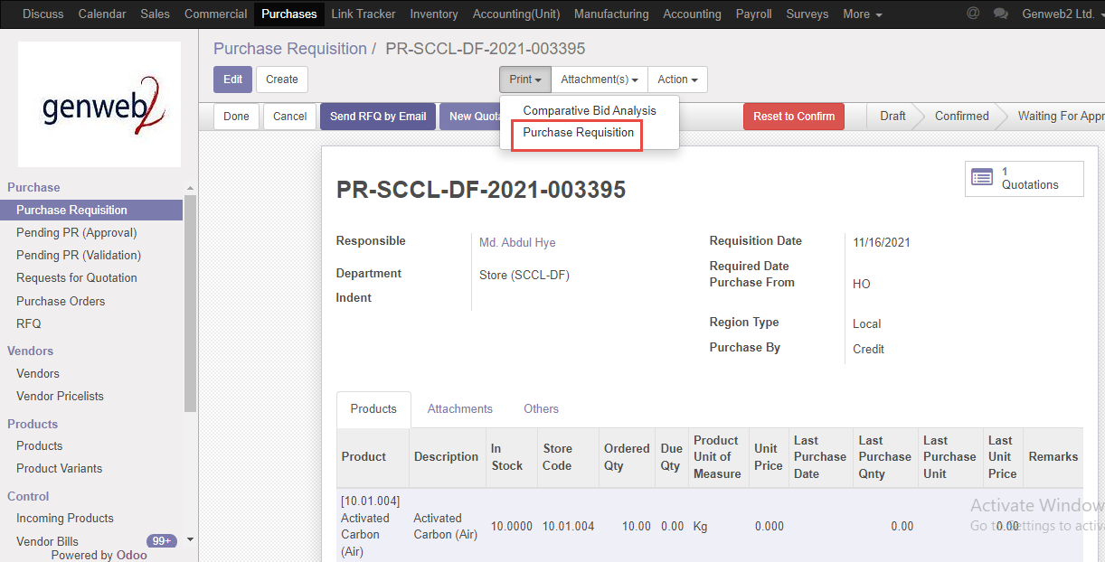

Figure: Approved PR

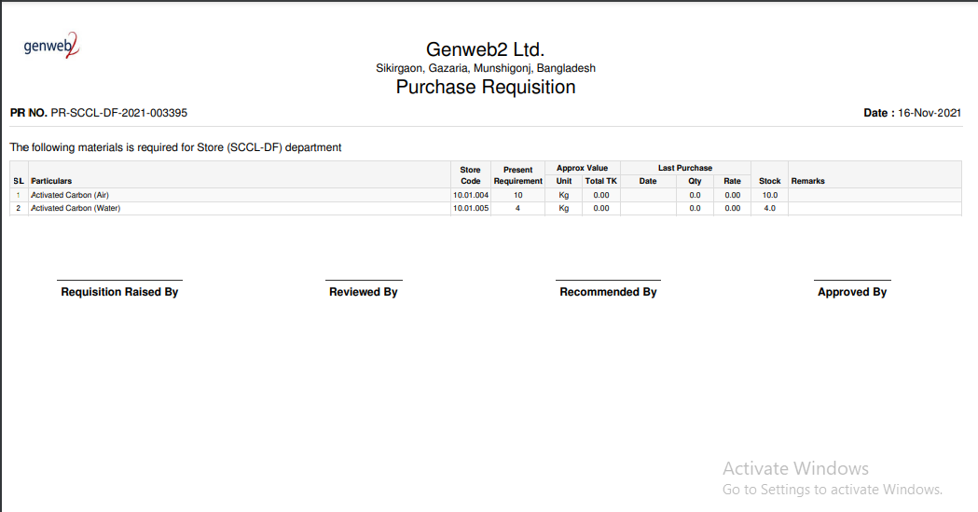

Figure: Print PR

# 3. Send RFQ

Procurement user will get Approved PR list then He/she will create Send RFQ for Comparative bid study report. Finally will select a quotation to confirm order.

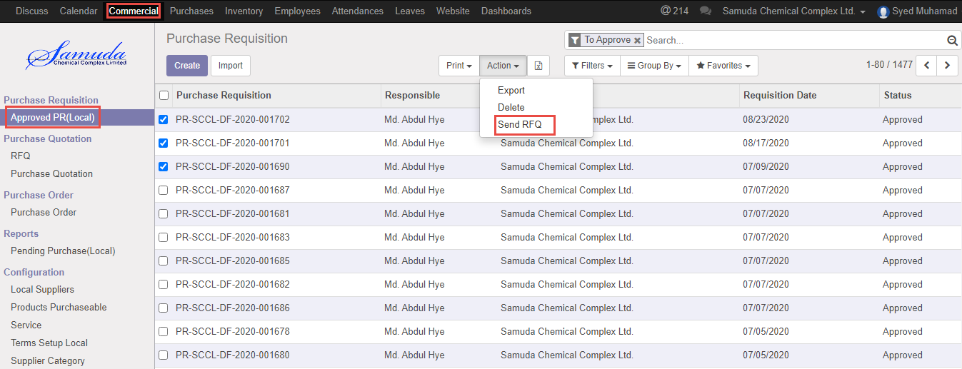

Figure: Send RFQ

## 3.1 Send RFQ create by Purchase user (Local)/Manager

Procurement users/Manager will send RFQ.



Figure: Send RFQ

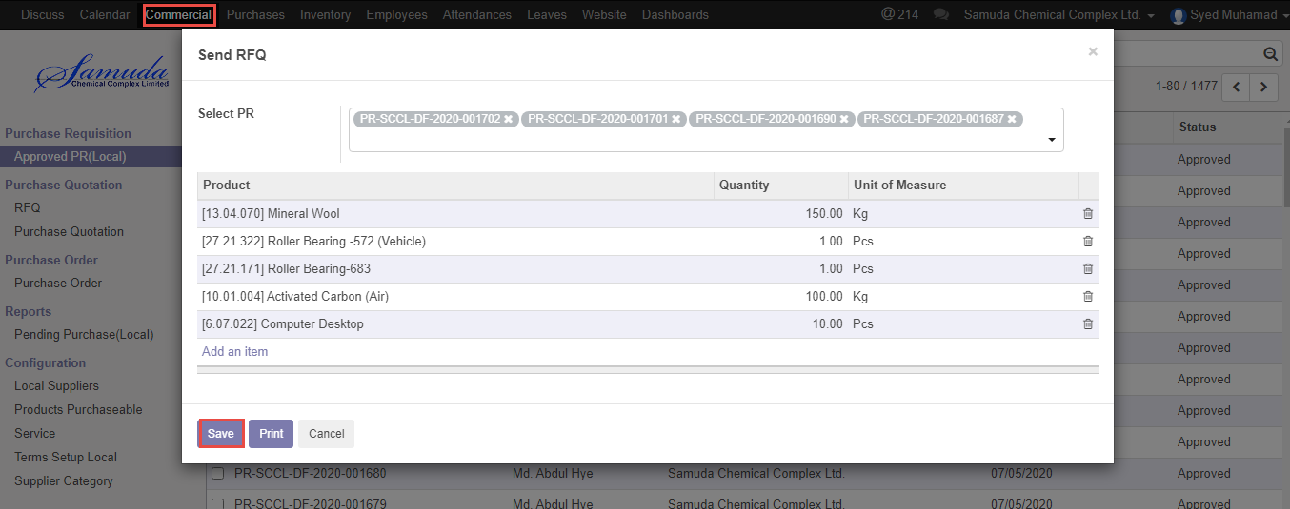

Figure: Send RFQ creation

# 4. Comparative Bid Study

Procurement user will compare Supplier unit price after Send RFQ then finally will select a supplier to Purchase product.

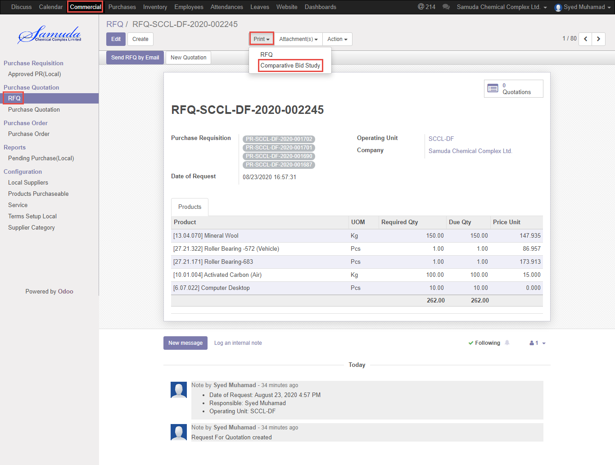

Figure: Comparative bid Study

## 4.1 Comparative bid study analysis by Purchase user (Local)/Manager

Procurement users/Manager will view Comparative bid study.



Figure: Comparative Bid Study

Comparative Bid study PDF reports.

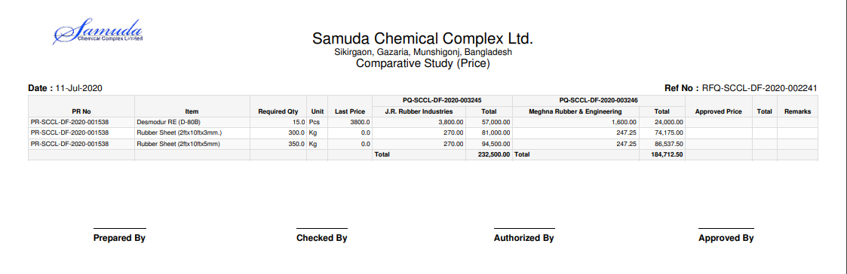

Figure: Comparative Bid Study PDF format

# 5. View Purchase quotation

Procurement user will view purchase quotation .Purchase quotation will create after completion Send RFQ.

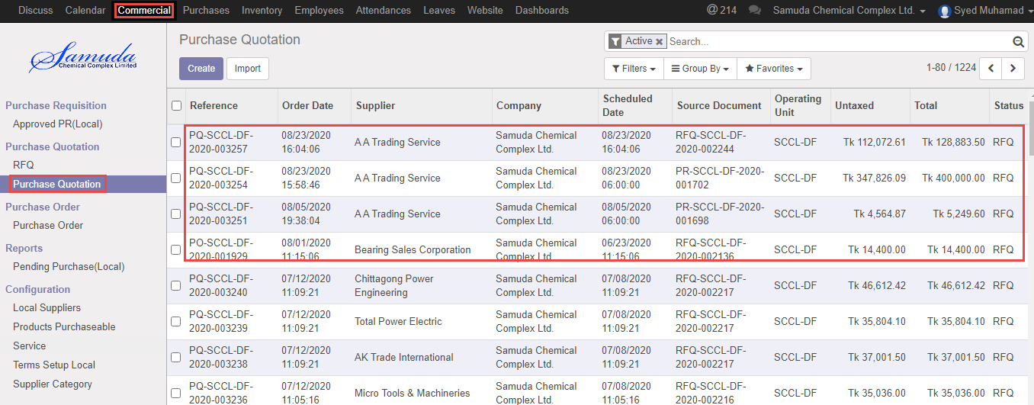

Figure: Purchase quotation list view

## 5.1 View Purchase quotation by Purchase user (Local)/Manager

Procurement users/Manager will view purchase quotation.



Figure: Purchase Quotation

# 6. Purchase order

A purchase order (PO) is a commercial document and first official offer issued by a buyer to a seller indicating types, quantities, and agreed prices for products or services. It is used to control the purchasing of products and services from external suppliers. Purchase orders can be an essential part of enterprise resource planning system orders.

Indent/requisition is a purchase order often placed through an agent under specified conditions of sale.

The issue of a purchase order does not itself form a contract. If no prior contract exists, then it is the acceptance of the order by the seller that forms a contract between the buyer and seller.

## 6.1 Confirm Purchase order by Purchase user (Local)/Manager

After compare Bid analysis user select a Purchase quotation to Confirm purchase order.

Procurement users can confirm order.

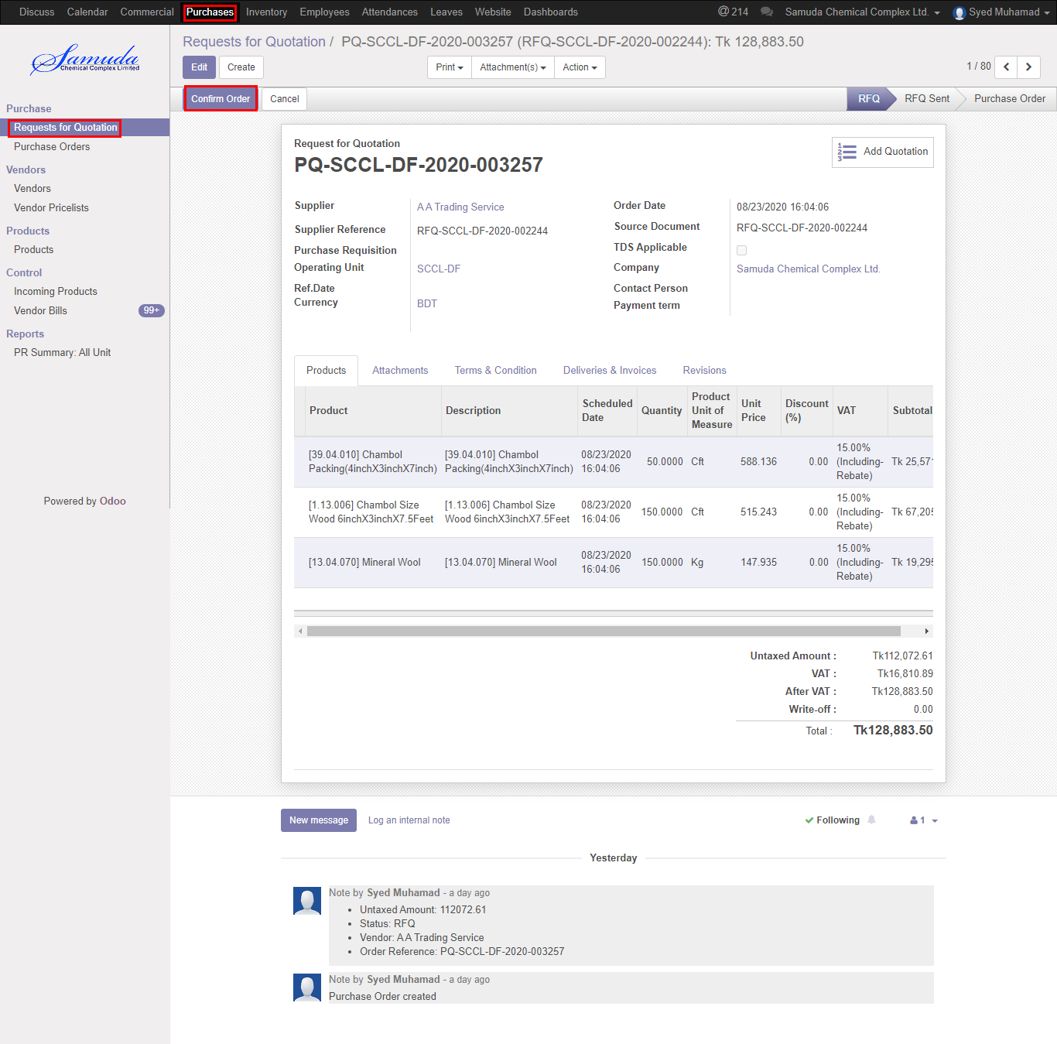

Figure: Confirm PO

Below window will open after confirm then

**Region type**: Select region type. If select local then after approve order will view local purchase department, If select foreign then will get Foreign purchase after PO Approved.

**Purchase By:** Select purchase by.

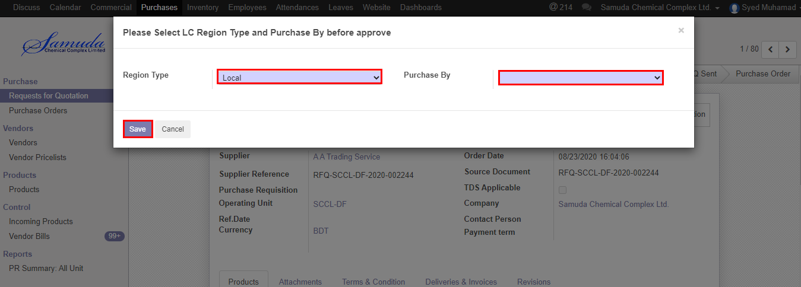

Figure: Confirm PO

## 6.2. View Purchase order

Procurement user will view purchase order. User also capable to search with PO number, PR number, LC number etc.

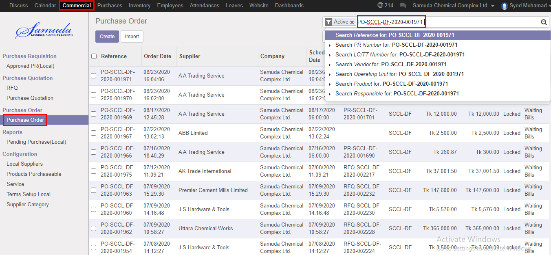

Figure: Search PO

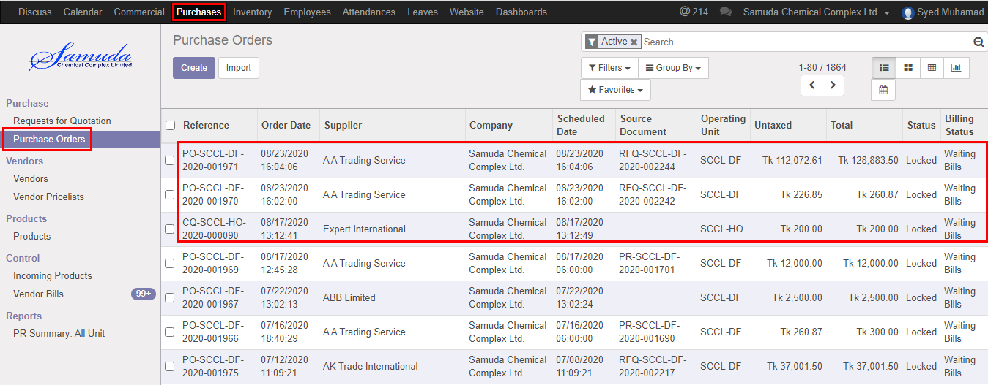

Figure: Purchase order list view

## 6.3. Print PO View from approved PO by Purchase user/Manager

Procurement user/manager will view print PO. 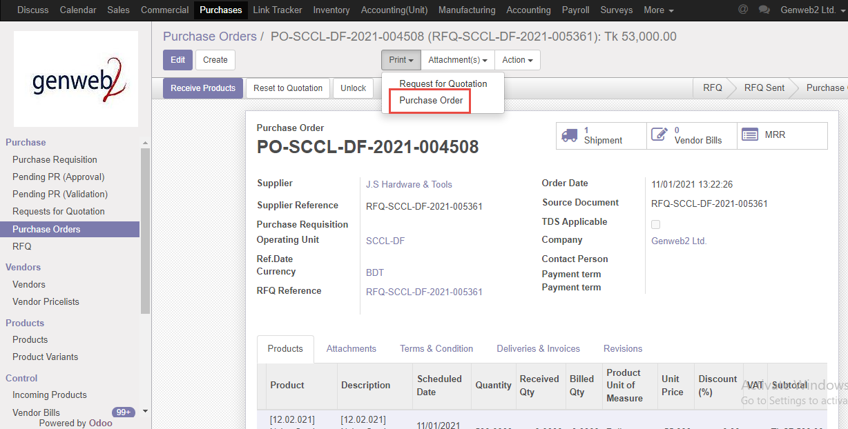

Figure: Purchase order

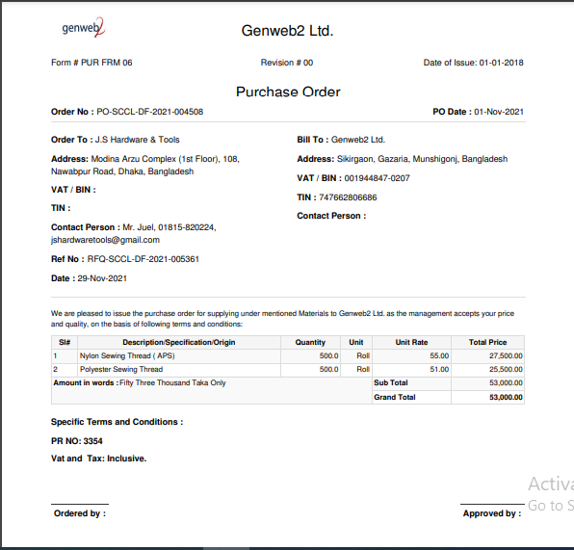

Figure: Print PO

## 6.4. MRR PO against view by Purchase user/manager

Procurement user/manger MRR will view PO against. After sound stock update will go for MRR approve. After two level approver MRR will approved.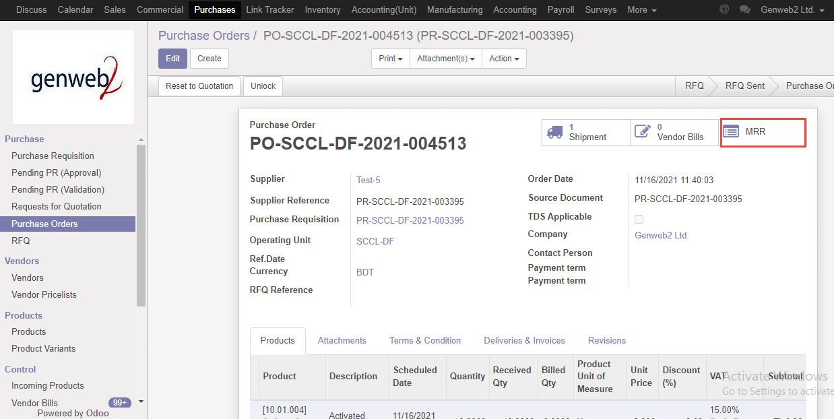

Figure: MRR view

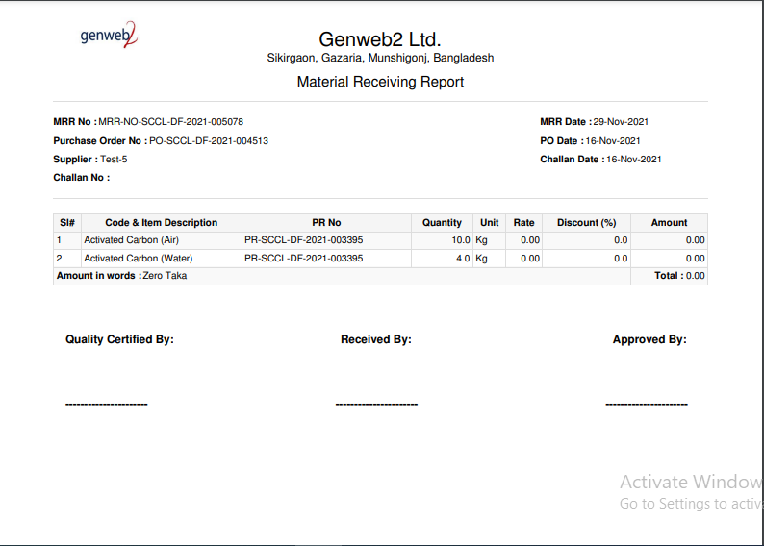

Figure: Print MRR

# 7. Vendor Bills

Vendor bill payment will happen two ways one is purchase order against & other is Supplier against. Vendor bill will create/validate by procurement user. Finally accounts manager will approve vendor bill.

## 7.1 Vendor bill creation PO against initiate by Procurement user

Vendor bill will be Initiate/Edit by procurement user

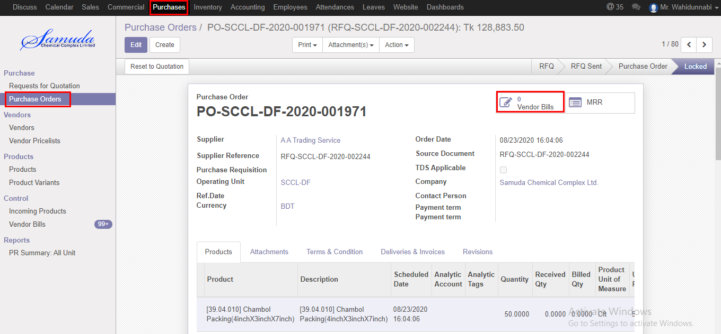

Figure: Vendor bills

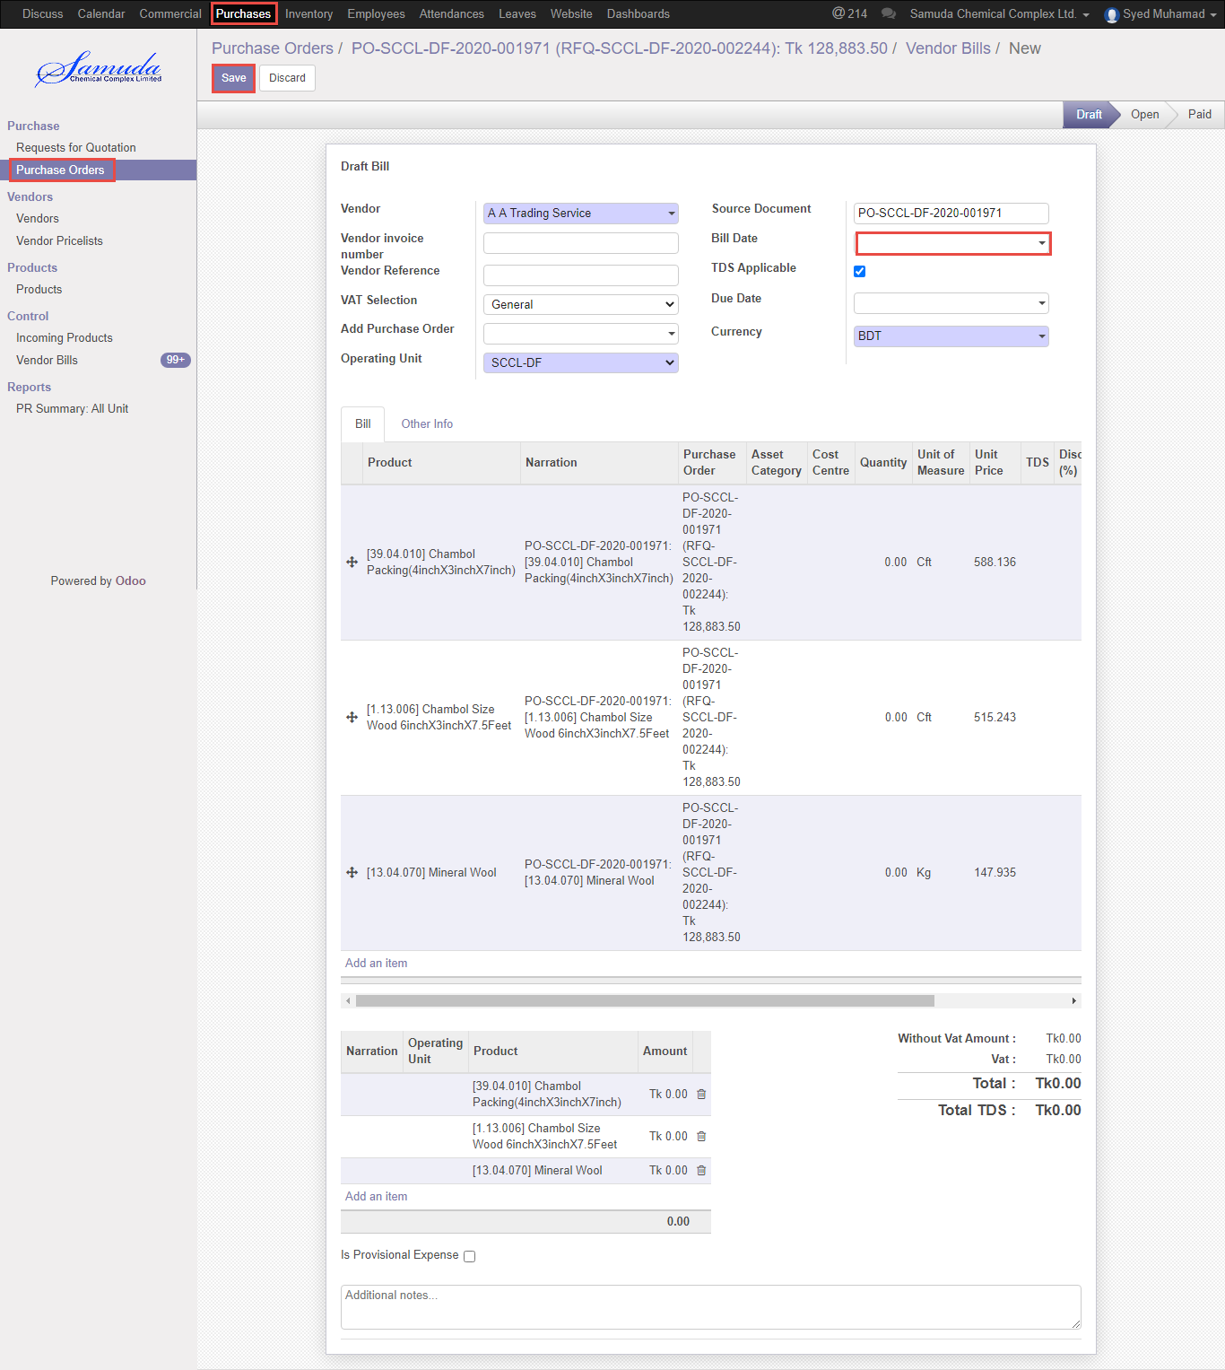

Figure: Vendor bill creation

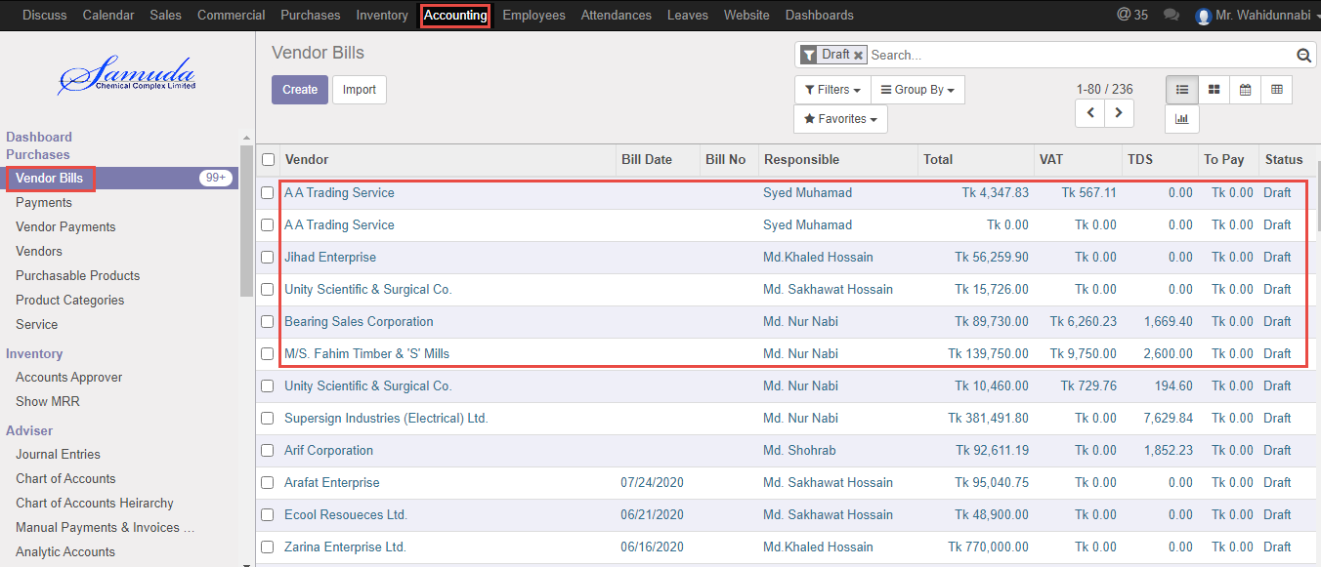

Figure: Vendor bills list view

# 

# 8. Reports

## 8.1 PR info Report view by Procurement user/Manager

To see the PR info Report.

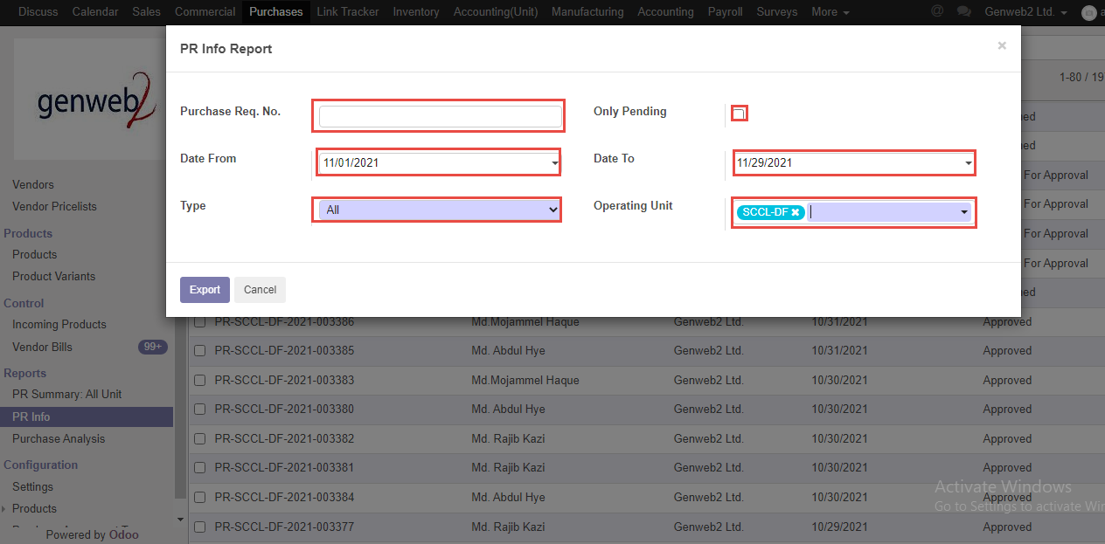

Figure: PR info Report print view

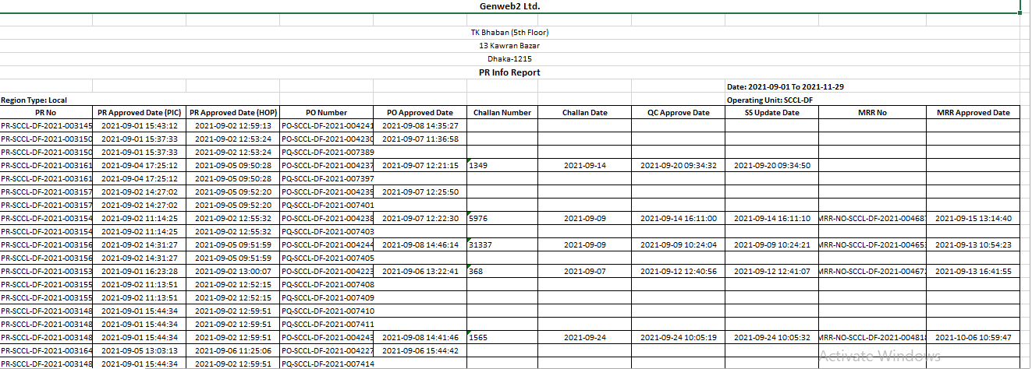

Figure: PR info reports Excel format

## 8.2 Purchase Requisition Summary Report view by Procurement user/Manager

To see the Purchase Requisition Summary Report.

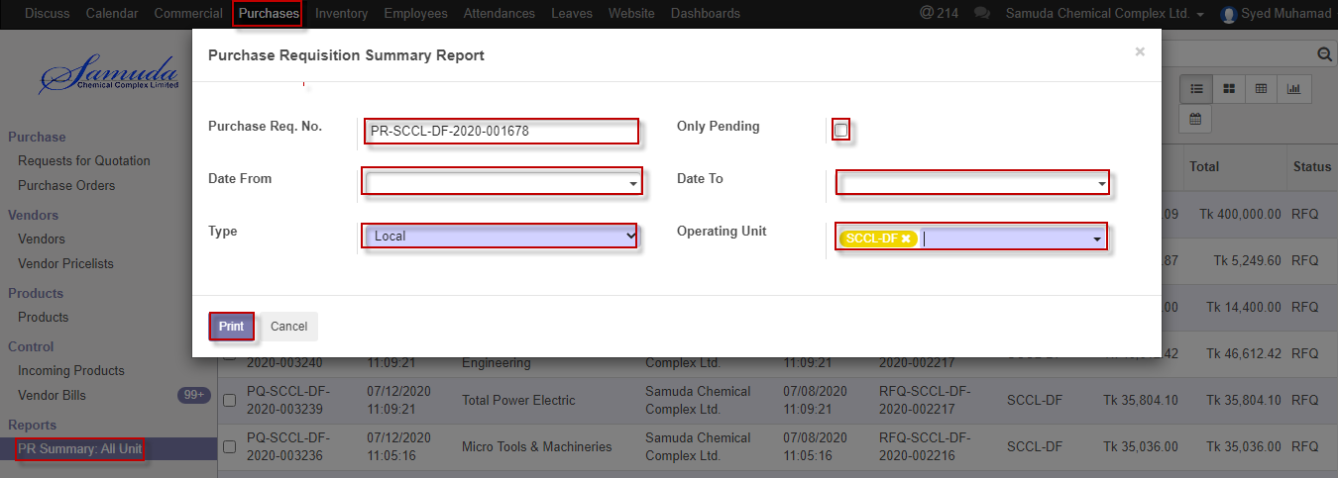

Figure: Purchase Requisition Summary Report print view

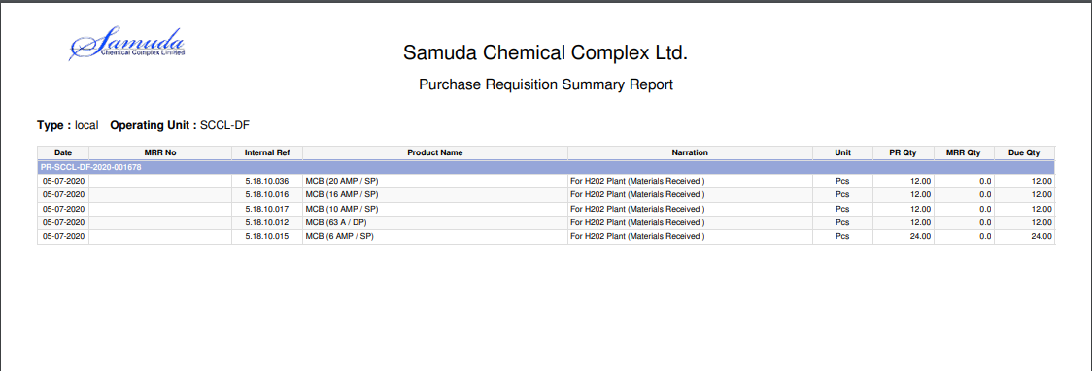

Figure: Purchase requisition summary reports PDF format

## 8.3 Pending purchase local reports view by procurement user/ Manager

To see the Pending purchase local reports.

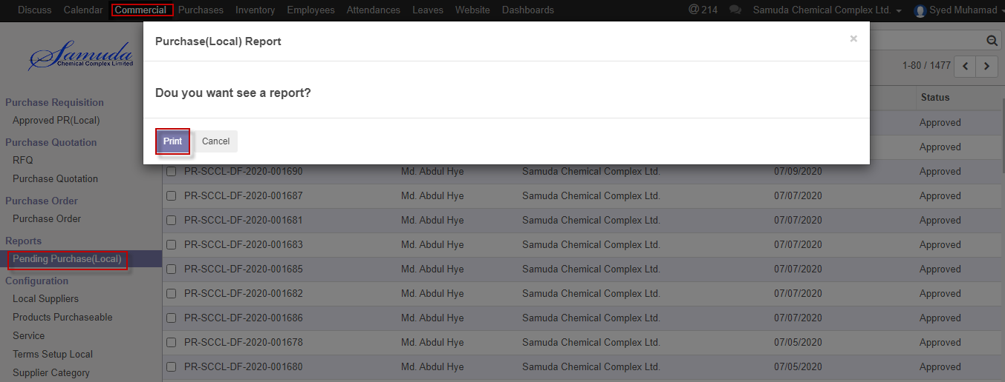

Figure: Pending purchase (local) report print view

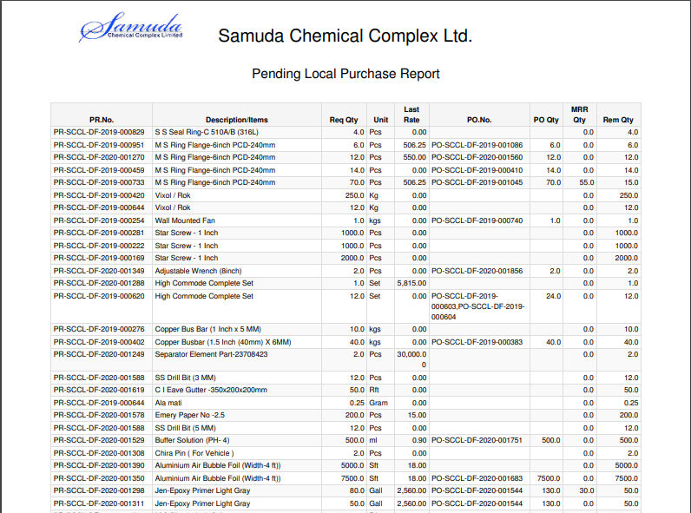

Figure: Pending purchase (Local) reports PDF format